**Web Application Report**

*By: Deniss Kirillovs*

*Date of Submission: 18/12/2020*

**Introduction**

Following the specification provided to me, I was tasked with designing and developing a web application suited for a portfolio. I took heavy inspiration from Hugo Peter’s website as it looked the most appealing website.

**Overview**

Reading the specification told me that the website should be well designed, and have relevant information on it. This website must contain a proper way of allowing the user to navigate through the web application for PC using a navigation header, or for the Mobile users – a working hamburger menu. The website application should encompass multiple pages that the user can navigate between, as well as a consistent header and footer all throughout the pages. Moreover, the version control system that I would be using is github.com which allows for my work to be backed up securely and allow me to recall specific versions of the designed website.

**Program Design**

First of all, I will be explaining my **index.html**:

**<header>**

My header is consistent all throughout my webpage – meaning the header content does not change regardless of the page loaded.

My index **<header>** navigation-bar consists of 6 hyperlinks, 4 of which automatically scroll through the page using anchors in a smooth motion once clicked – this was designed to allow the user to go to the part of the website that they want to read without forcing them to be redirected into another page. Although this is very easy to do, I encountered a problem in which the different sections of my page would be covered by the header when clicked. I fixed this by writing this:

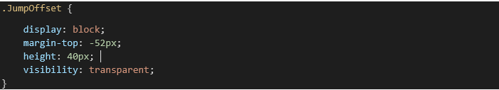

The margin-top is there to push down the offset by -52px and the height is to match the header. So when the user presses on one of the buttons in the header, it will navigate to the **<JumpOffset>** instead.

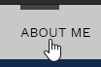The other 2 buttons “Personal Work” and “Resume” are hyperlinks that go to different pages – “Personal Work” redirects the user and “Resume” opens another tab and redirects the user to that tab.

Additionally, there is a very unique feature that makes navigating through the page more satisfying – a small animation where a small black bar fills up when the user hovers over the buttons:

And lastly I made the navigation-bar to be responsive by adding a “Hamburger Menu” which is an icon that the user can press when the screen resolution is below 1070px in width – when the users screen resolution falls below the 1070px, the web application will set the header to display: none which hides it and brings the hamburger icon. Inside this menu are the same exact buttons that you see on the header above 1070px resolution.

**<body>**

My body consists of 5 sections. The “Slideshow” which is a gallery of clickable images the user can cycle through. The “About Me” which is just plain text with a header above it – I used w3schools website for references and help on the slideshow, the reason why I chose the documentation website instead of something like Youtube is because there is more relevant and not outdated information on that particular topic. “My Projects” section where it displays 4 hyperlinked images that go to another page. I had an issue with how it would display on a small screen, as the images are static and are not prone to resize according to the resolution. But I found an easy fix that used the media queries that detect when screen resolution has decreased below a certain amount which allow them to wrap when it changes.

An example of this is seen below:

Higher Resolution

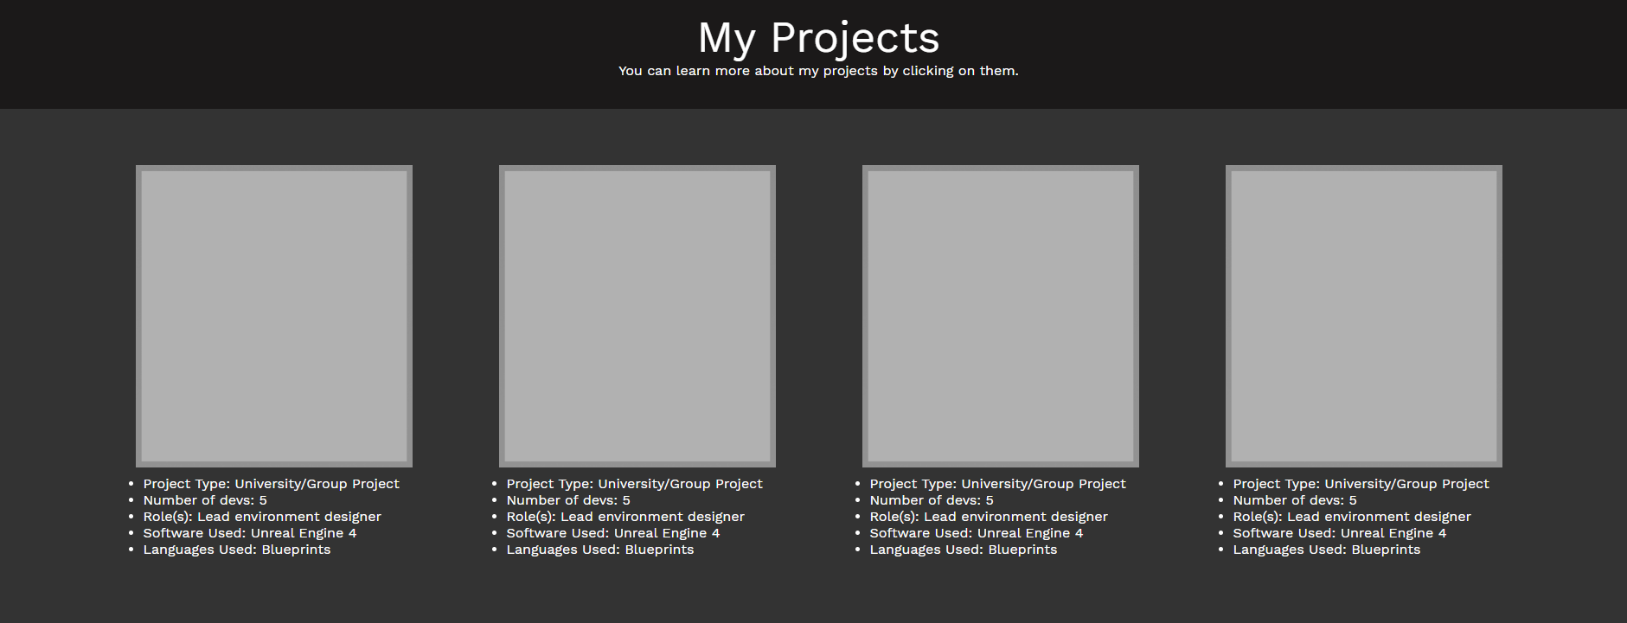

Smaller Resolution

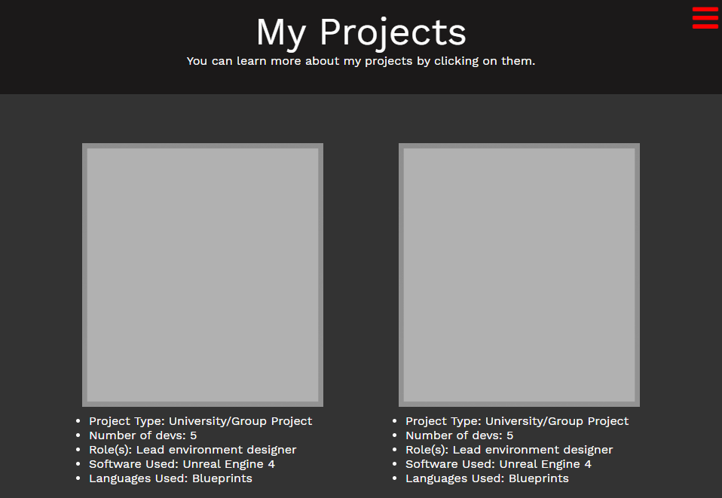

And lastly the “Contact” page with a head and some text below it – below that text are some hyperlinked social icons that open a new tab when clicked. I also implemented some “on hover” effects - when the user hovers over the icons, they will increase in opacity for some visually nice feedback

**<footer>**

My footer is pretty simple, it consists of one line of text and a grey background which is always displayed at the bottom of all pages.

**Personal Work Page**

“Personal Work” is the section which covers 3D models. This part consists of two sections, the head and the content – the head is just a plain white text over the darker grey background with the width of 100% of the screen and height to encompass all the text.

The content section is wrapped with a flex-box container that allows for a responsive page. Inside this container are the five model-viewers that can be rotated by the player’s mouse or finger. Below the models is a small box with description about the model in white text.

**My Projects Pages**

Following the Personal Work section, next up is the “My Projects” section which will show information about the Game project that the user has clicked.

This page consists of 3 Sections;

* Header – Large header text in centred in the middle of the screen
* Image
* Project Information

**Analysis and Conclusion**

To analyse this web application, it is the most flexible when it comes down to resizing, it can adapt naturally to its resolution with no problems. By having flex containers, it is quite easy to add more content inside without needing to really tinker with CSS. The colours that I chose are very calm and subtle – using darker colours, I can allow the user to look at the website with comfort. Downside to this website is that the hamburger menu icon overlaps the menu content.

In conclusion, this definitely has room for improvement, and I would have to say the roadmap for my website would be first by improving the hamburger menu and as well as polishing content inside My Projects.

**References**

Pal, R., 2016. *Git and GitHub Beginner Tutorial 5 - Branching and Merging*[online]. Available from: <https://www.youtube.com/watch?v=GZILYABgAoo&ab_channel=AutomationStepbyStep-RaghavPal> [Accessed Nov 25 2020].

Pal, R., 2016. *Git and GitHub Beginner Tutorial 7 - Git Tags - what, why, when and how* [online]. Available from: <https://www.youtube.com/watch?v=govmXpDGLpo&ab_channel=AutomationStepbyStep-RaghavPal> [Accessed Nov 25 2020].

w3schools, 2020. *How TO – Slideshow* [online]. Available from: <https://www.w3schools.com/howto/howto_js_slideshow.asp> [Accessed Nov 26 2020]

Powell, K., 2016. *How to create an awesome navigation bar with HTML & CSS* [online]. Available from: <https://www.youtube.com/watch?v=FEmysQARWFU&t=316s&ab_channel=KevinPowell> [Accessed 24 Nov 2020].

Peters, H., 2020. *Hugo Peters – Game Programming & Design Portfolio*[online]. Available from: <https://hugo.fyi/> [Accessed 23 Nov 2020].

Sketchfab, 2020. *The best 3D viewer on the web* [online]. Available from: <https://sketchfab.com> [Accessed 11 Dec 2020].

Traversy Media, 2016. *Flexbox CSS In 20 Minutes*[online]. Available from: <https://www.youtube.com/watch?v=JJSoEo8JSnc&ab_channel=TraversyMedia> [Accessed Nov 29 2020].